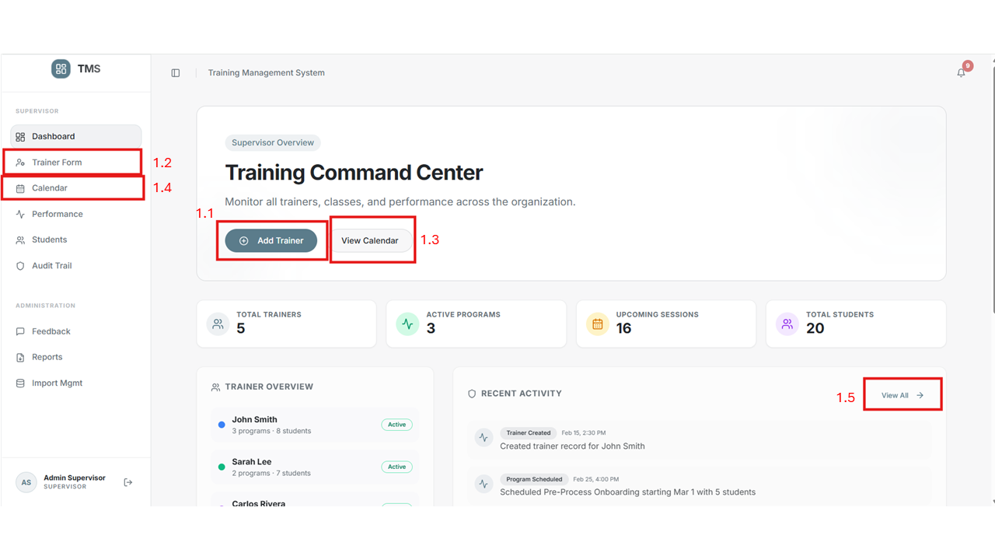
  - – The User (Admin) would click and would take to a trainer form
  - The Trainer form would contain details to enter
  - View calender would take to the calender page
  - Calender page has the information of the Scheduled session created
  - View all would take to the Audit trail which will show the recent activities taken on the app

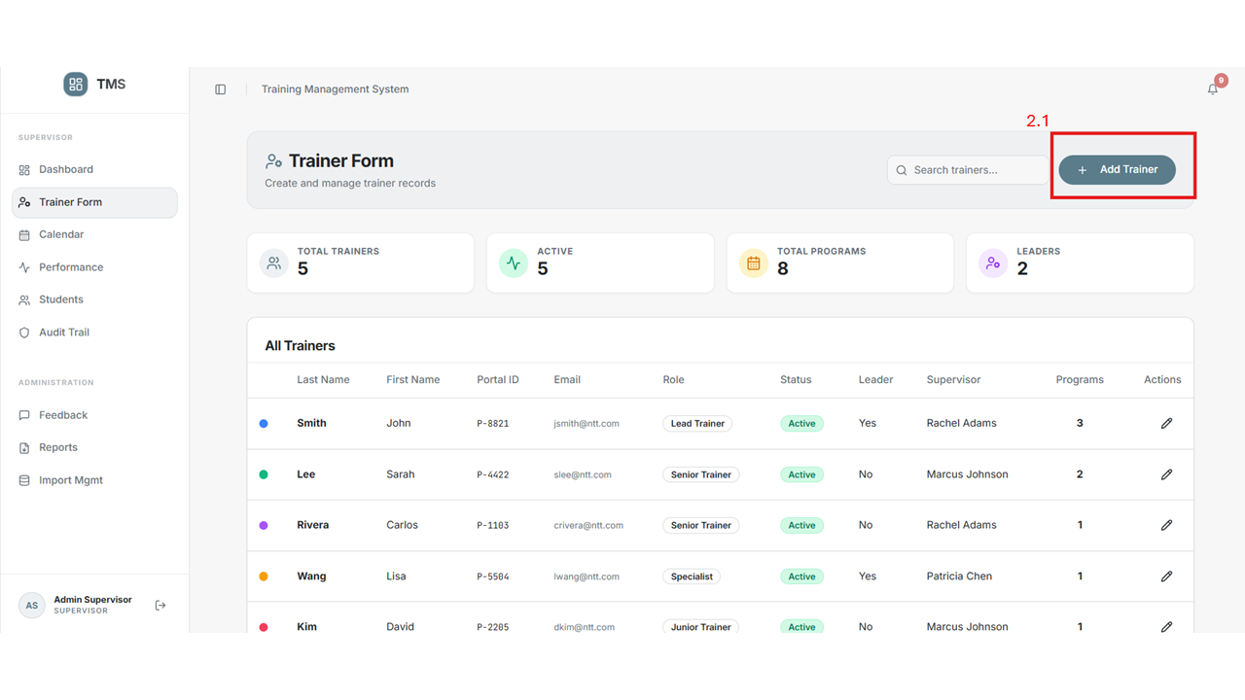
2.1 Admin will click the Add trainer and add the trainer with the information
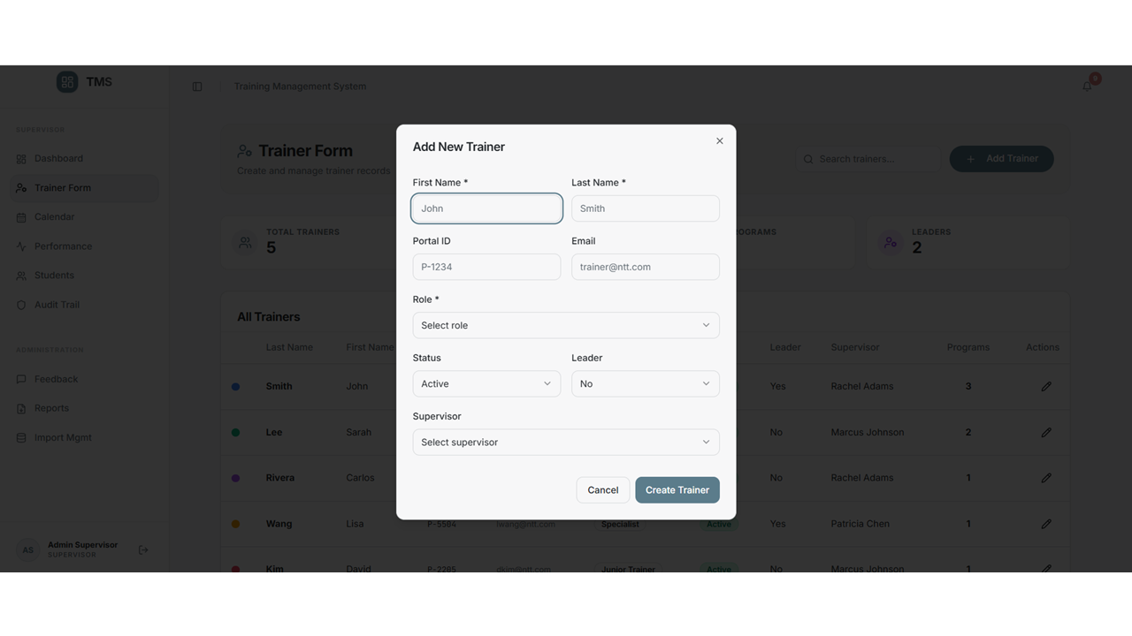

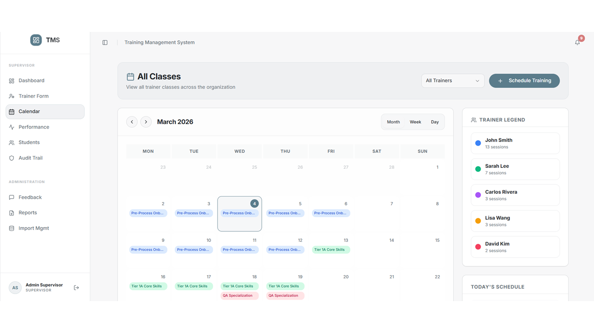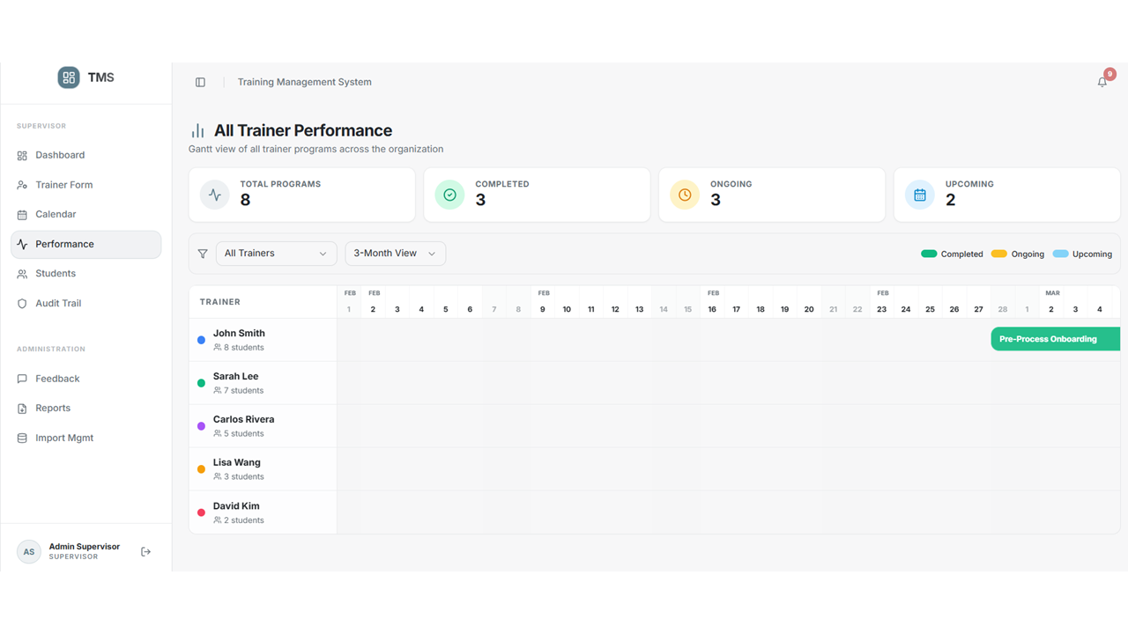
Performance Page would show the admin the Completed Ongoing and Upcoming event for all the trainers
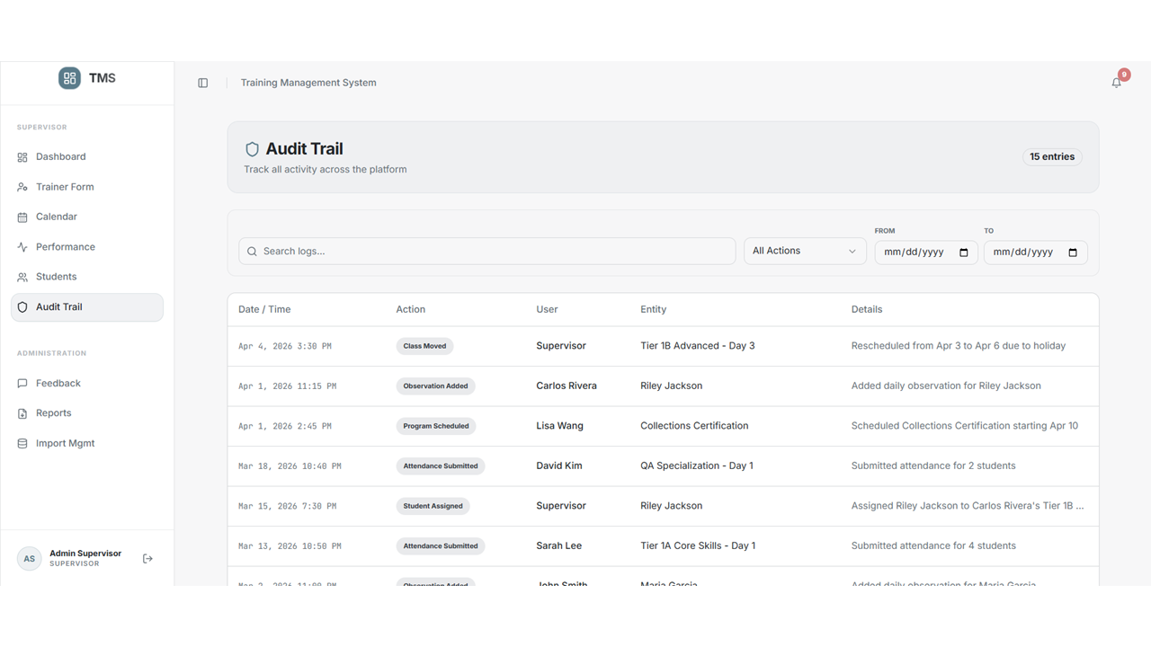

Audit Trail will show all the recent activities done from the Trainer side

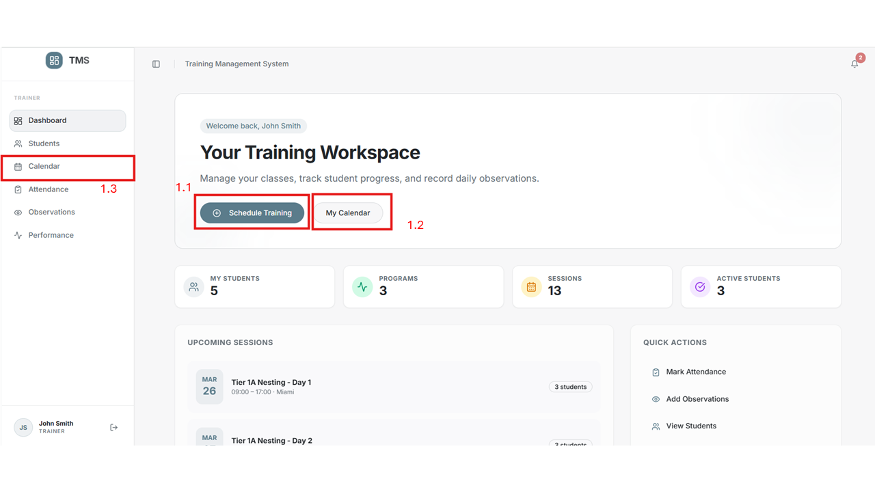
  - The User(Trainer) will the schedule training and add the session details
  - My Calender would take to the Calender page
  - Calender page would show the scheduled session

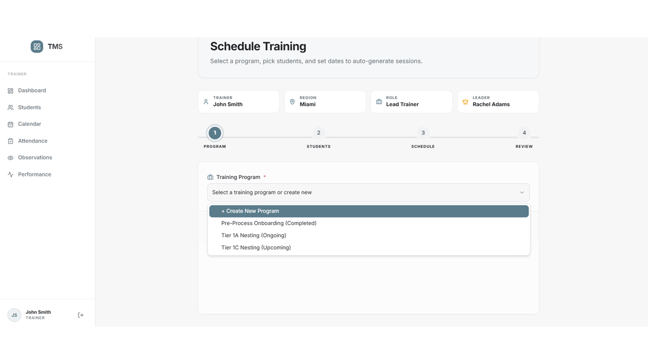

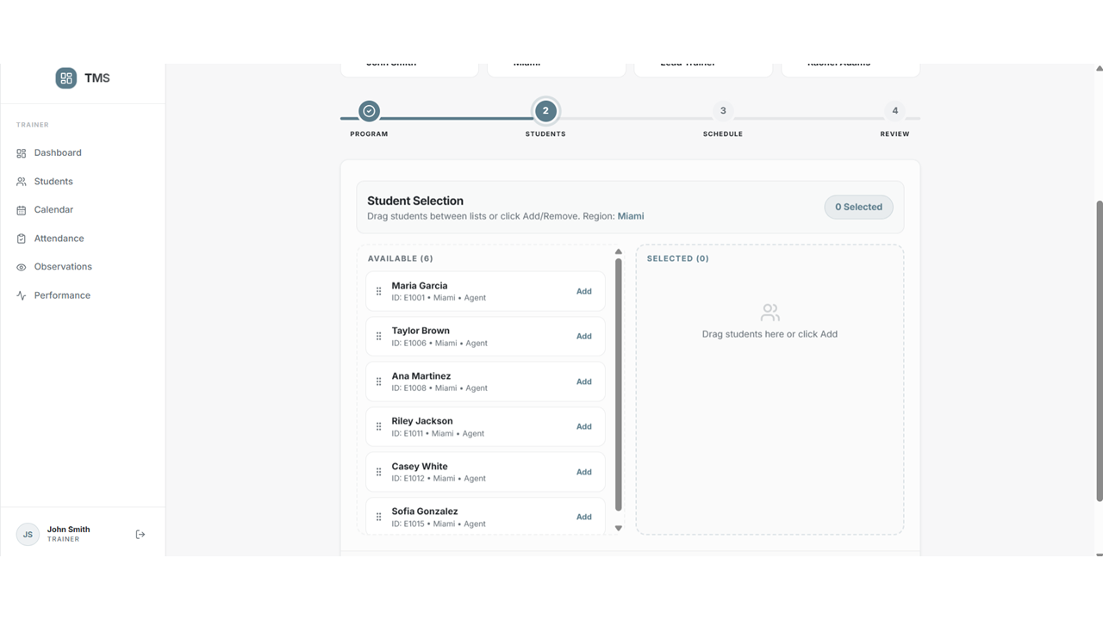

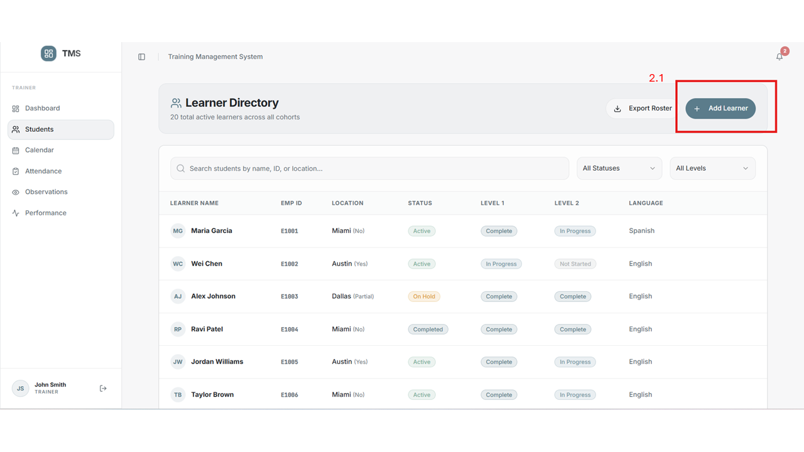
2.1 Add leaner would let the User(Trainer) add students into the system

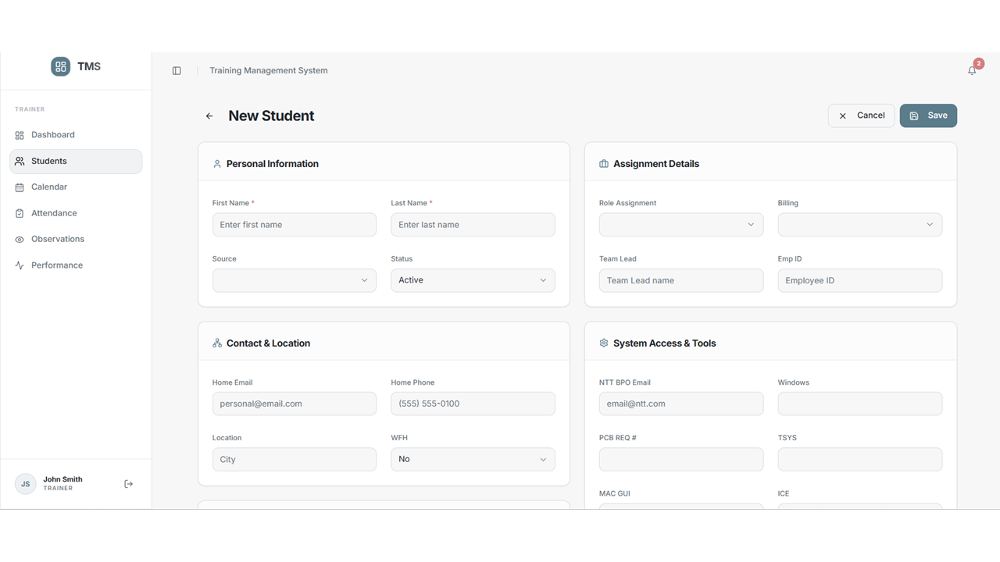

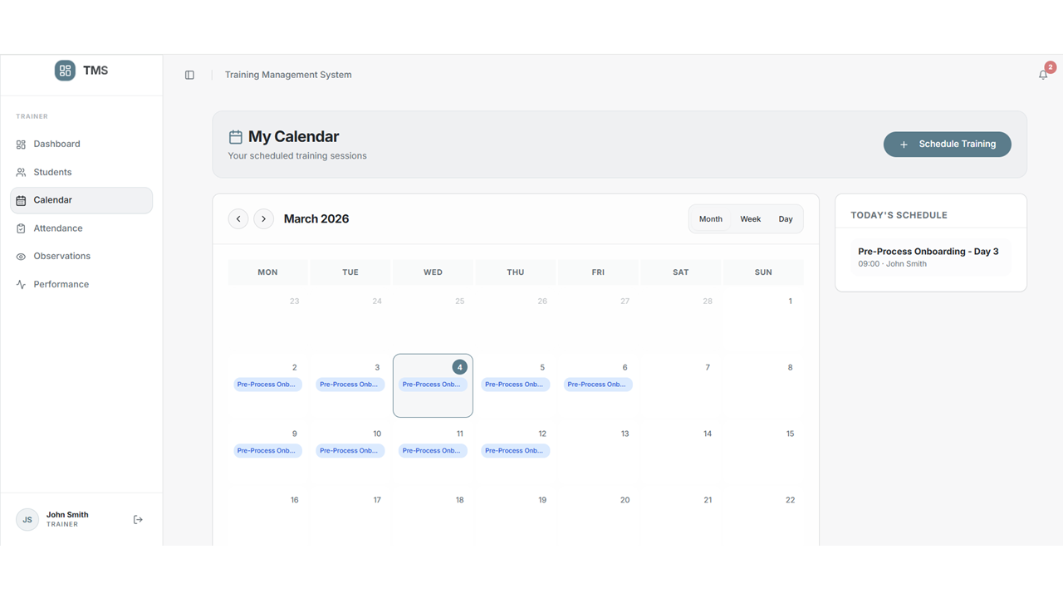
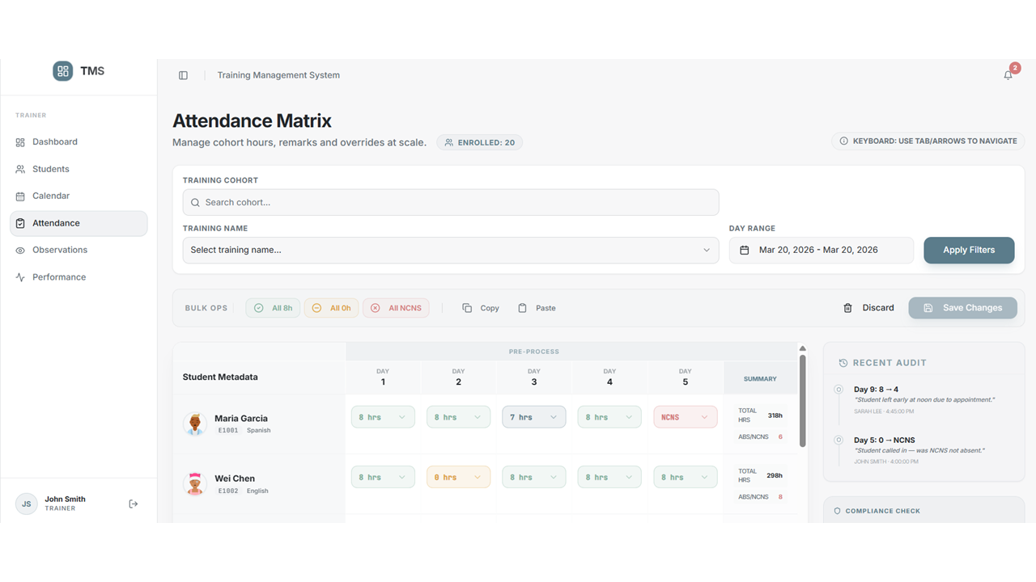

Attendance Matrix would allow the User(Trainer) mark the attendance for the Students

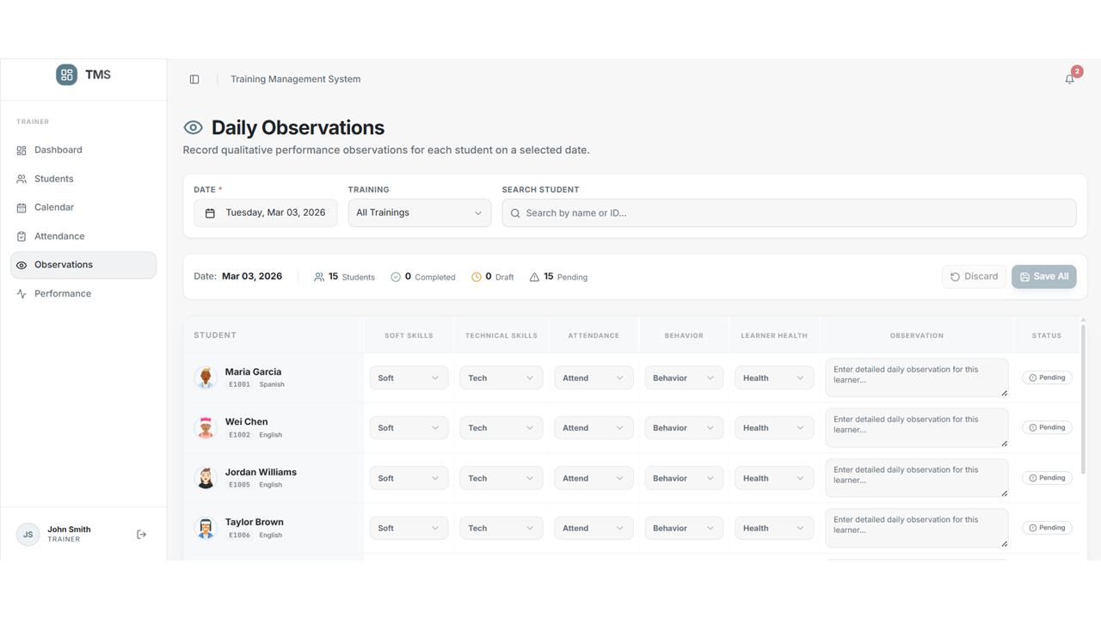
Daily Observation where the User(Trainer) would be able to mark the performance of the students on a regular basis

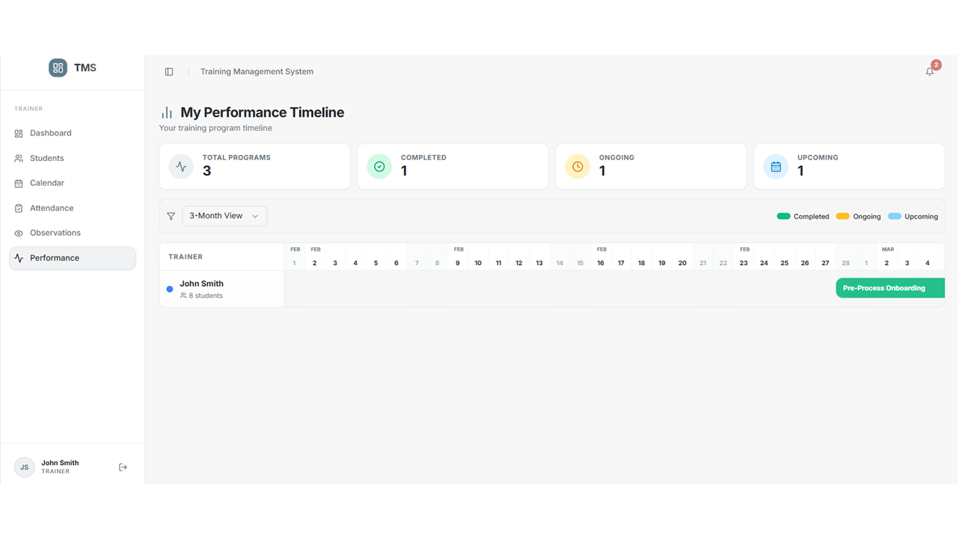

My performance Timeline would show the Sessions completed ongoing and upcoming for the User(Trainer)

